**CHAPTER II**

**METHODOLOGY**

This chapter presents the research design, study location, study respondents, sampling procedure, research instrument, data gathering procedure, and data analysis technique.

**RESEARCH DESIGN**

Developmental research is a type of study that was utilized to create QR Code Attendance Monitoring with Class Scheduling Management System.

Developmental research is defined as the scientific study of creating, producing, and assessing instructional programs, procedures, and products that must meet internal consistency and effectiveness requirements. This is distinct from simple instructional development, which is simply the act of ensuring that what is taught works. Developmental research was appropriate for system design and development.

Furthermore, in order to get input and make changes that made the generated program usable, the researchers a quantitative research survey was used. A survey is a research technique used to collect data from a predetermined group of respondents in order to get information and insights on a variety of topics of interest.

**Locale of the Study**

The researchers conducted the study at Bago Elementary School wherein the researchers were affiliated with the institution.

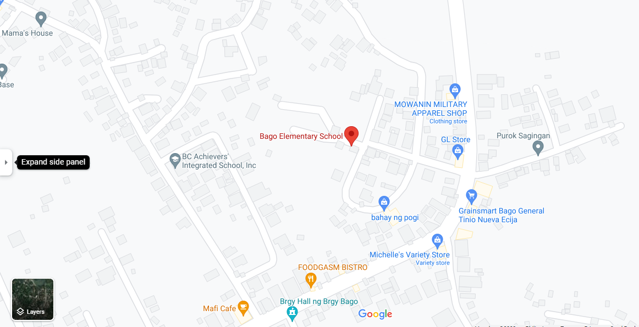Figure 2 shows the map of Bago Elementary School

**Respondents of the study**

The respondents for this study will consist of various individuals associated with Bago Elementary School. Firstly, school administrators, comprising the principal, vice-principal, and administrative staff, will be included to gauge their perspectives on the QRAMSMS implementation's impact on school operations. Secondly, teachers will form a crucial part of the sample as they will be using the system to manage class schedules and attendance records.

Additionally, non-teaching staff members, including administrative personnel, clerks, and others involved in administrative tasks, will provide insights into the system's effect on their daily responsibilities. IT staff, responsible for implementing and maintaining the QRAMSMS system, will offer their expertise. This comprehensive set of respondents will enable a holistic evaluation of the QRAMSMS system's implementation at Bago Elementary School.

**Sample and Sampling Procedure**

The selection of responses in this Purposive research will be determined by the researchers conducting the sampling process. Purposive sampling is a methodology in which non-probability sampling is employed. In this approach to research, researchers exercise their own judgment to determine which individuals from the population should participate in their surveys. It involves the use of specific criteria to carefully choose suitable respondents who can provide meaningful insights for the study.

Furthermore, this method goes beyond random selection and aims to select individuals who possess characteristics or knowledge relevant to the research objectives. This approach is valuable when researchers seek to target specific expertise, experiences, or perspectives within a population. By employing purposive sampling, researchers can enhance the quality and relevance of their data, ultimately leading to more robust and insightful research findings.

**Research Instrument**

This investigation was carried out using an manual survey questionnaire, which is organized research that the target audience fills out on the manual paper. The researchers used hard copy as a survey platform.

Furthermore, a questionnaire was used as the research tool in this study. A questionnaire is a collection of research or survey questions. Questions posed to respondents in order to gather precise information that will be used to collect relevant data and make it available for analysis. The manual survey questionnaire employed ordinal as a rating system of variables on the Likert items to measure the responses of the respondents.

The research instrument was based on the study's problem statement, which has three (3) parts. The first part the system's design was identified and developed using the agile model's stages. The second part described how IT specialists evaluated the system's technical aspects using ISO 25010 criteria. The last part determined how the end user believes the system works.

**Data Gathering Procedure**

The researchers' first task was to get authorization from their research adviser to conduct such a survey for the study, before handing over the respondent's authorization Check out the site and the questionnaire. After The system was then tested by the responders that participated in the manual survey to participate in the survey, fill out on the questionnaire survey. The Researchers were prepared to resolve any issues that occurred, additional issues or questions expressed by the respondents.

**Data Analysis**

To gain a deeper understanding of the study's results, the researchers employed various analytical techniques, including verbal interpretation, calculation of means, and determination of percentages based on the responses provided by the study participants. These analytical approaches were instrumental in dissecting and comprehending the data collected during the research process.

In their quest to explore the study's findings in greater detail, the researchers utilized verbal interpretation, which involved carefully analyzing and interpreting the participants' responses in a qualitative manner. This allowed them to extract nuanced insights and identify recurring themes or patterns within the data. Additionally, mean calculations were used to derive numerical summaries that provided a quantitative perspective on the central tendencies of the responses. By calculating percentages, the researchers were able to gauge the prevalence or distribution of specific responses or variables, offering a valuable perspective on the data's composition.

In summary, the researchers employed a multifaceted approach, encompassing both qualitative and quantitative methods, to delve deeper into the study's findings. This comprehensive analysis allowed for a more thorough exploration of the data and contributed to a richer understanding of the research outcomes.